2024TL/05
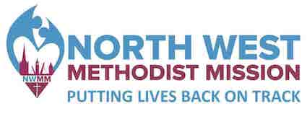 Reference Number:

EQUAL OPPORTUNITIES MONITORING

Northwest Methodist Mission is committed to achieving equality of opportunity in employment on the basis of merit. Applicants are requested to complete this questionnaire which will be separated from your application form upon receipt and used for statistical purposes only.

Date of Birth: ____/____/________

Gender: Male Female Other _______________

Community Background: We are required by The Fair Employment and Treatment (NI) Order 1998 to monitor the perceived community background of employees and applicants. In accordance with the Monitoring Regulations 1999, we are asking you to indicate the community to which you belong by ticking the appropriate box below:

a) My background is that of the Protestant community

b) My background is that of the Roman Catholic community

c) I do not have either a Protestant or a Roman Catholic community background

Disability: A person has a disability if he or she has “a physical or mental impairment which has a substantial and long-term adverse effect on his or her ability to carry out normal day-to-day activities” (Disability Discrimination Act, 1995)

Do you consider yourself as having a disability? Yes No

If yes, please indicate which type of impairment(s) apply to you:
Learning Disability (e.g. Dyslexia, Down’s Syndrome)
Cognitive Impairment (e.g. Autism, Asperger Syndrome)
Progressive Illness / Health Condition (e.g. Cancer, HIV, Diabetes, Epilepsy)
Mental Health Condition (e.g. Depression, Schizophrenia)
Physical Impairment or Mobility Issues
Deaf or Serious Hearing Impairment
Blind or Serious Visual Impairment
Other (please specify)

Do any of the disabilities or conditions listed above have a substantial and long term adverse effect on your ability to carry out normal day-to day activities?
Yes No

